
BM108 Broadcast Antenna
88-108MHz
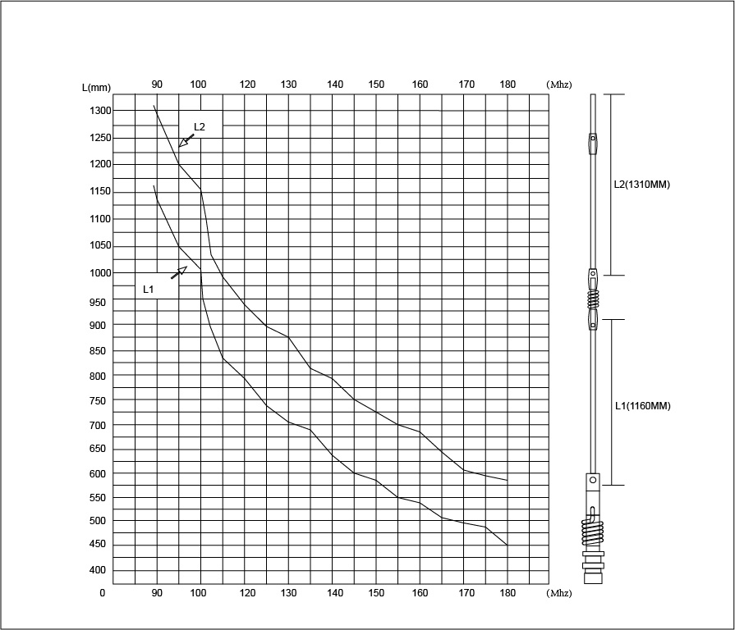

www.moonraker.eu

